Revisit - Angular Testing

What is Testing? – Checking the capability of code under different circumstance. Also, testing ensures that the delivery of error free code that performs well in all condition.

Why Testing is important?

Types of Testing?

Testing Pyramid – Unit Testing – Testing individual files (Component, service, Interface, Class, Pipe, Directive …). The unit testing code will be automatically created by angular cli.

By default, the name of test file will be <component-name-spec.ts> - The unit test code

Integration Testing – Testing to check end 2 end functionality. How one component is interacting with another component. How a service fetching the data from the API. Whether the call to API giving the proper response in the expected format. User interaction in the UI also will be tested.

What are all the tools available for Testing an Angular Application?

1. Jasmine – Unit Testing framework for JavaScript (Jasmine stand alone, SpecRunner.html, file.js, file-spec.js)
2. Karma – Test Automation Tool, (karma cli, karma, karma-chrome-launcher, karma-jasmine) karma.conf.js [SingleRun : false, the unit testing will be repeated whenever we make &save the changes to the angular app] - ng test(make sure the angular app is already running)
3. Protractor – e2e testing framework. (npm install protractor –save –dev, file.js, file-spec.js, conf.js) protractor.conf.js [User interaction – webdriver-manager is important] When we run e2e test, make sure the webdriver-manager is started. This is will be done as a SingleRun. Ng e2e (running the angular app is not compulsory)

Cypress – Powerful Test Automation tool similar to Selenium

<https://www.cypress.io/> - Official site

Cypress - It is a Test Runner. It makes e2e testing very simple. If you use the recorder option, and do the test of your application. All the operations performed on the web application will be recorder and saved as test script file. This test script can be executed n number of time in different browsers.

Installing Cypress

1. Using npm (npm install cypress)
2. Using the download files

<https://docs.cypress.io/guides/getting-started/installing-cypress>

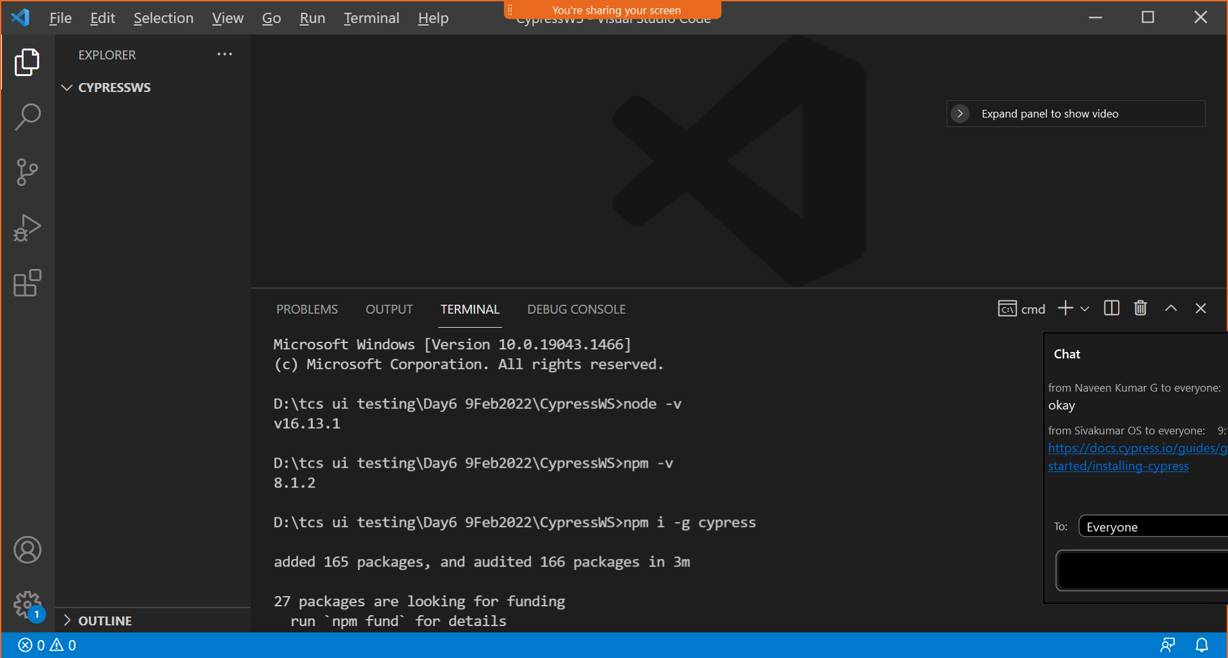

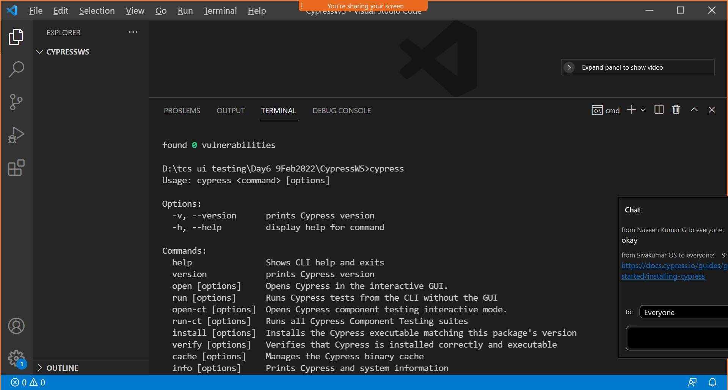

<https://example.cypress.io/todo>

<https://chrome.google.com/webstore/detail/cypress-recorder/glcapdcacdfkokcmicllhcjigeodacab> add Cypress recorder to your browser